

Former Anytime Fitness Space
For Lease

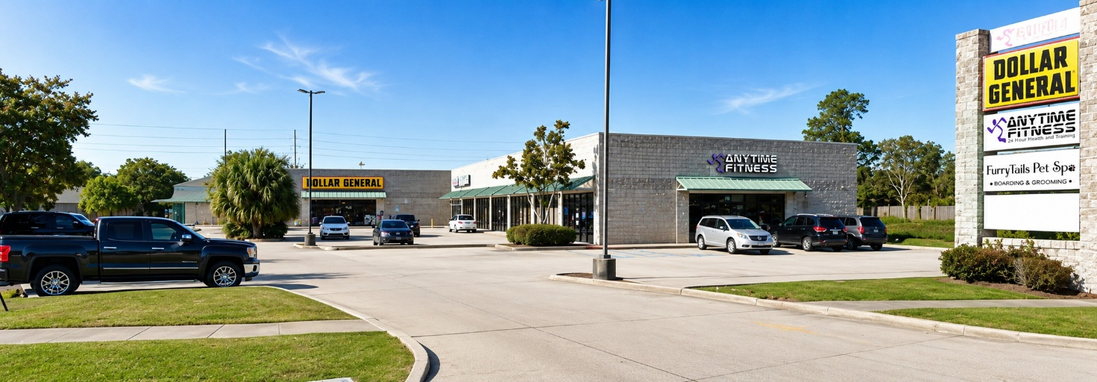

Location: 3176 Barataria Blvd., Marrero, LA 70072
Corner of Barataria Blvd and Pritchard Road

Available: Suite Size Rent
A&B 2,200sf $3,500/mo
C&D 2,200sf $2,500/mo
E 1,100sf $1,500/mo
A-E 5,500sf $6,000/mo

Zoning: C-2 commercial

Description: Newer Shopping Center surrounded by several subdivisions. Formerly an
Anytime Fitness gym which includes two restrooms, showers, a couple of
offices and two studio/workout rooms. The entire space is 5,500sf but can
be subdivided. Good parking. Neighboring tenants include the Dollar
General, Barber Shop, and a Nail Salon.


Listing Agent: Jon Cerruti with Jack Stumpf & Assoc
(504) 366-6800 jon@jackstumpf.com


May 2026

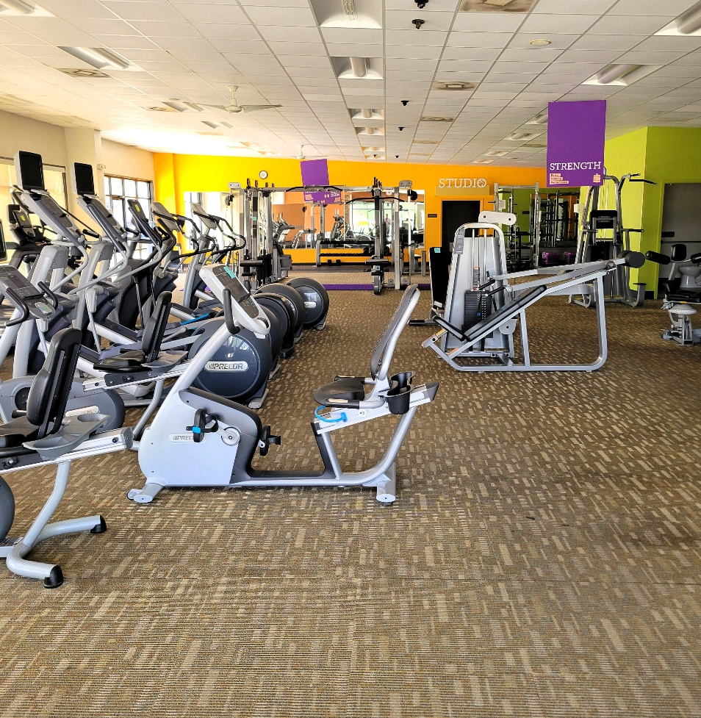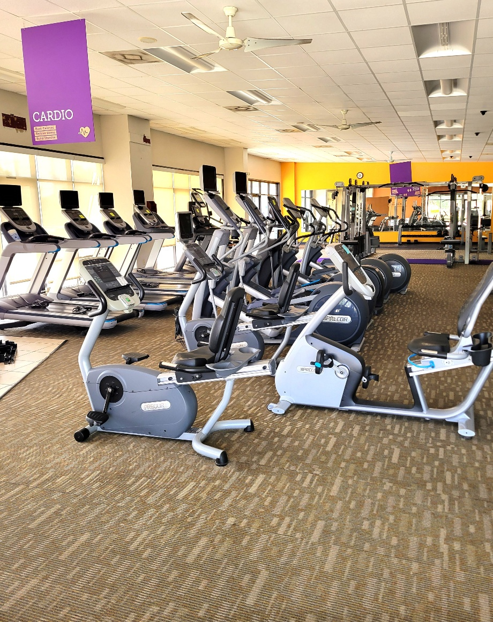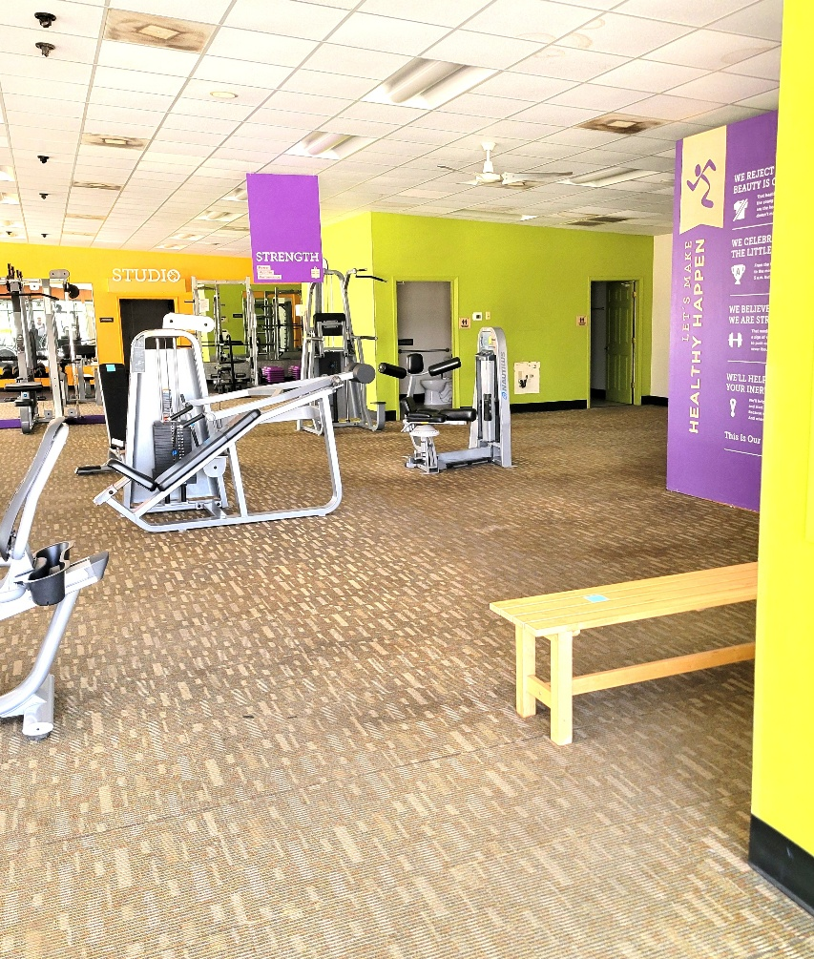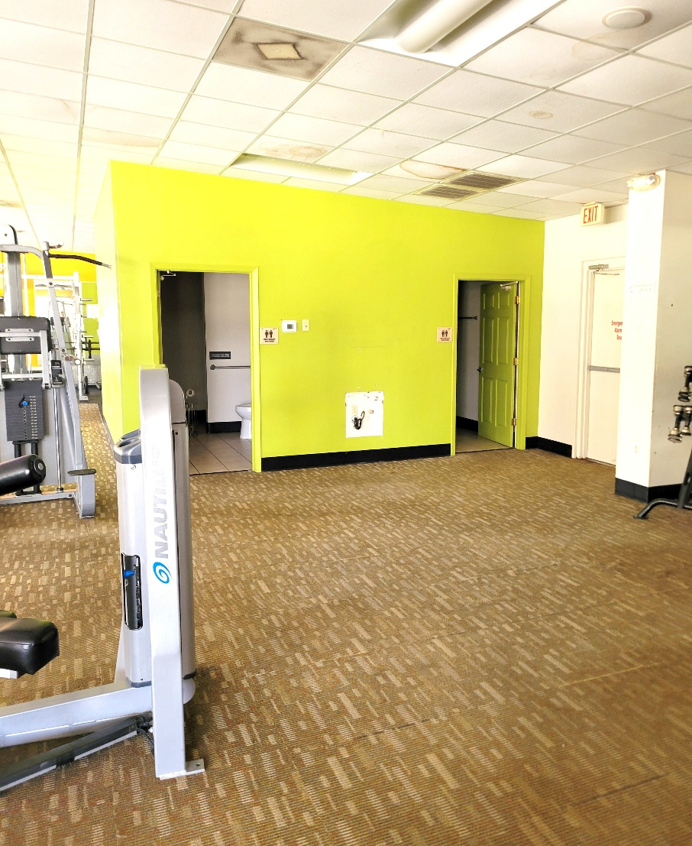
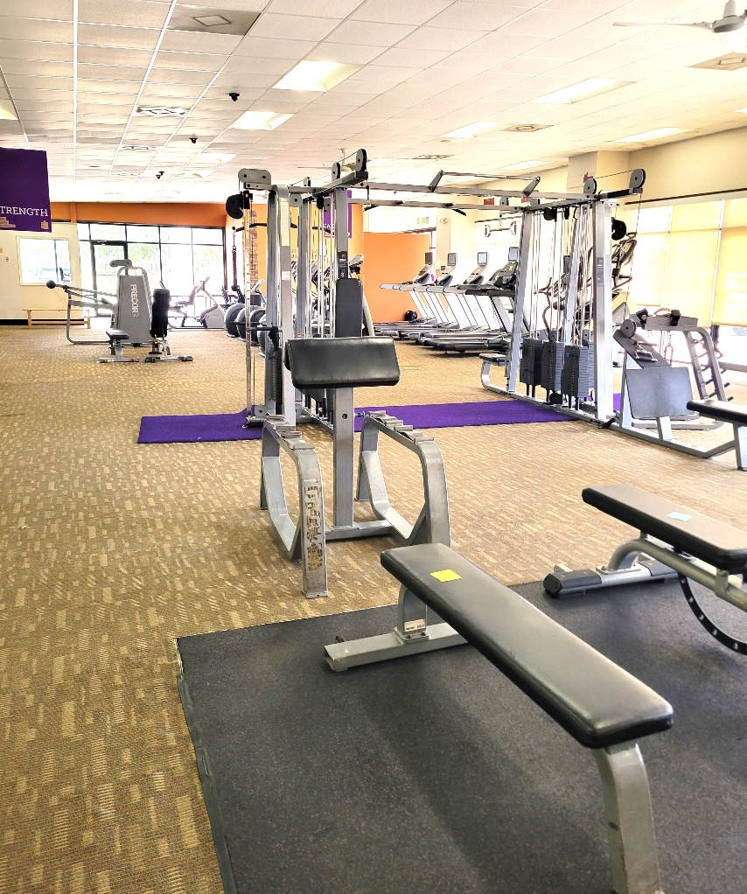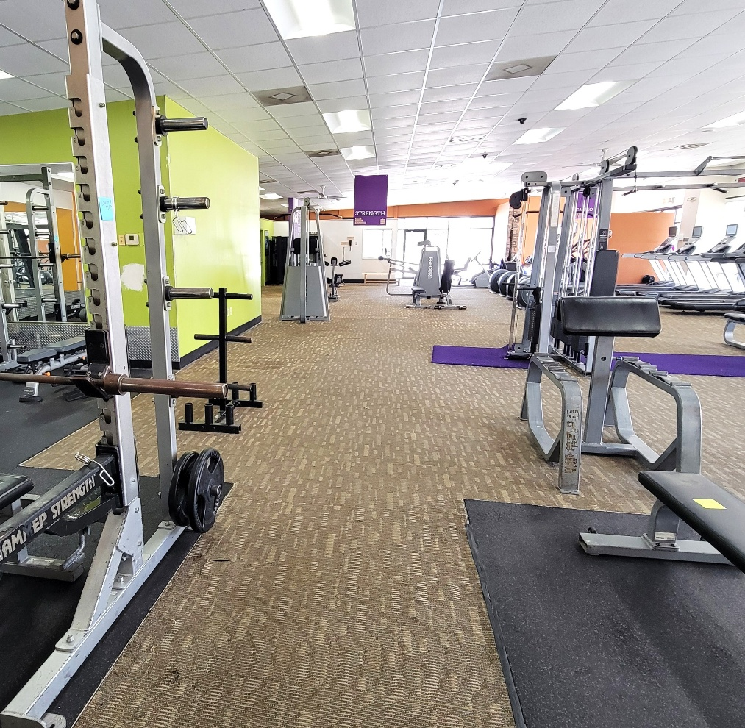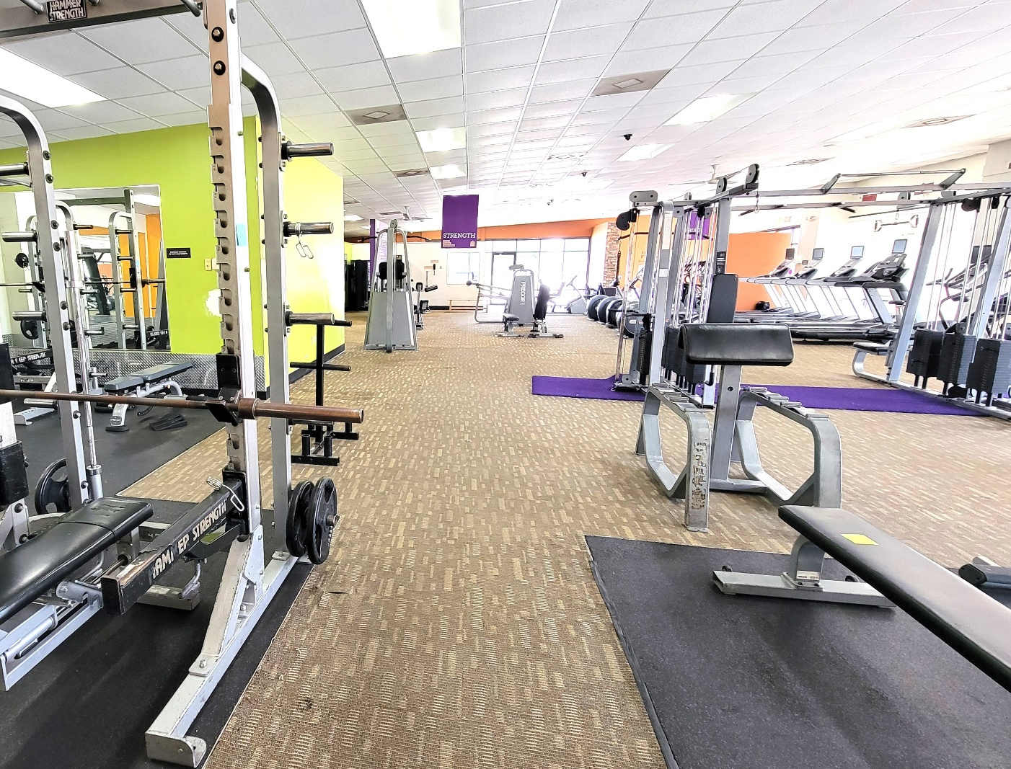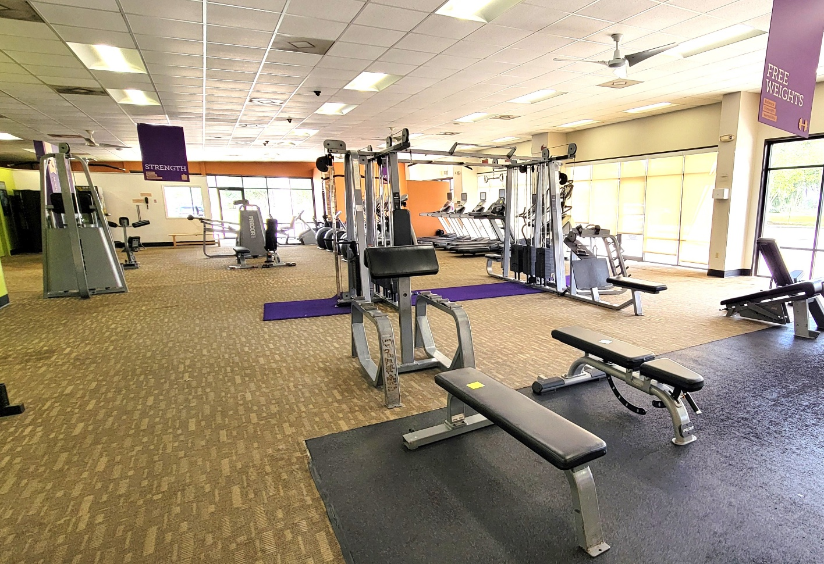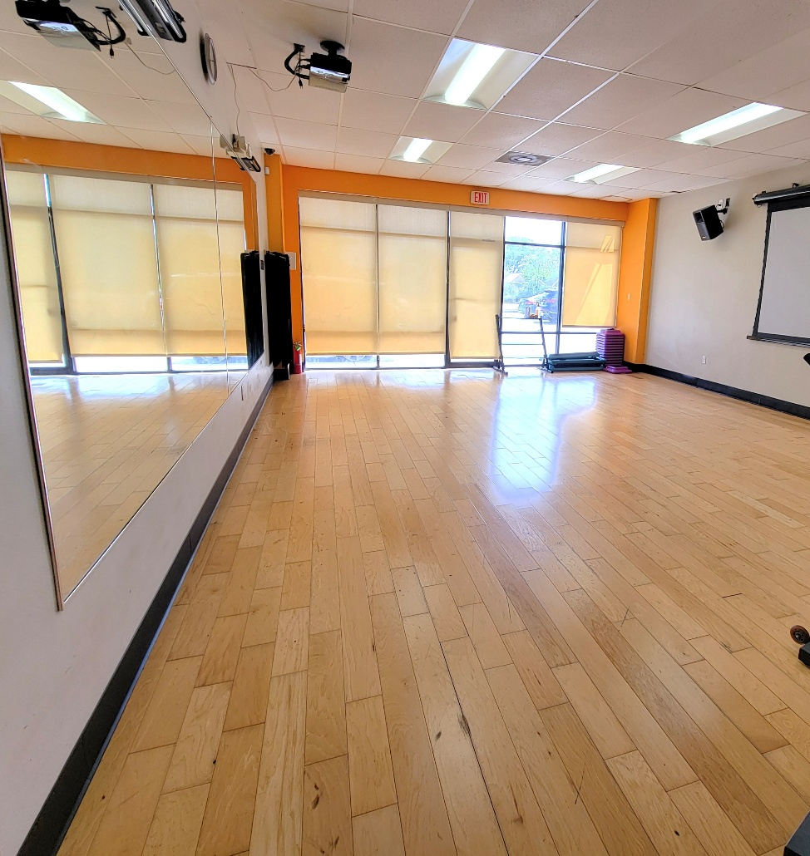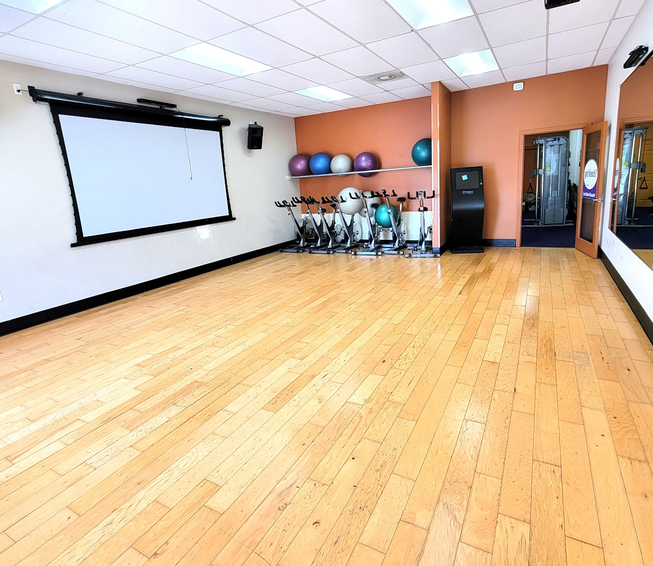
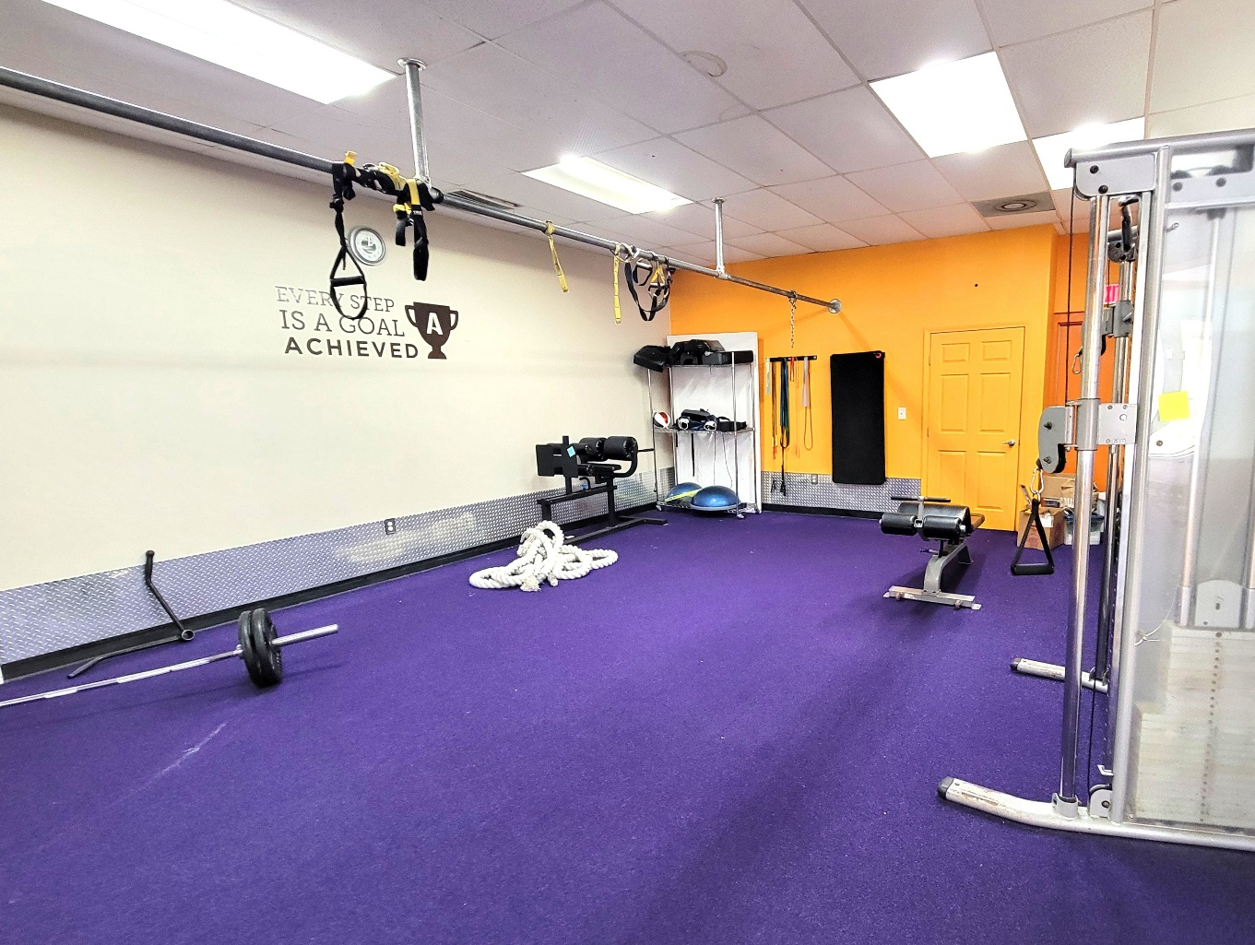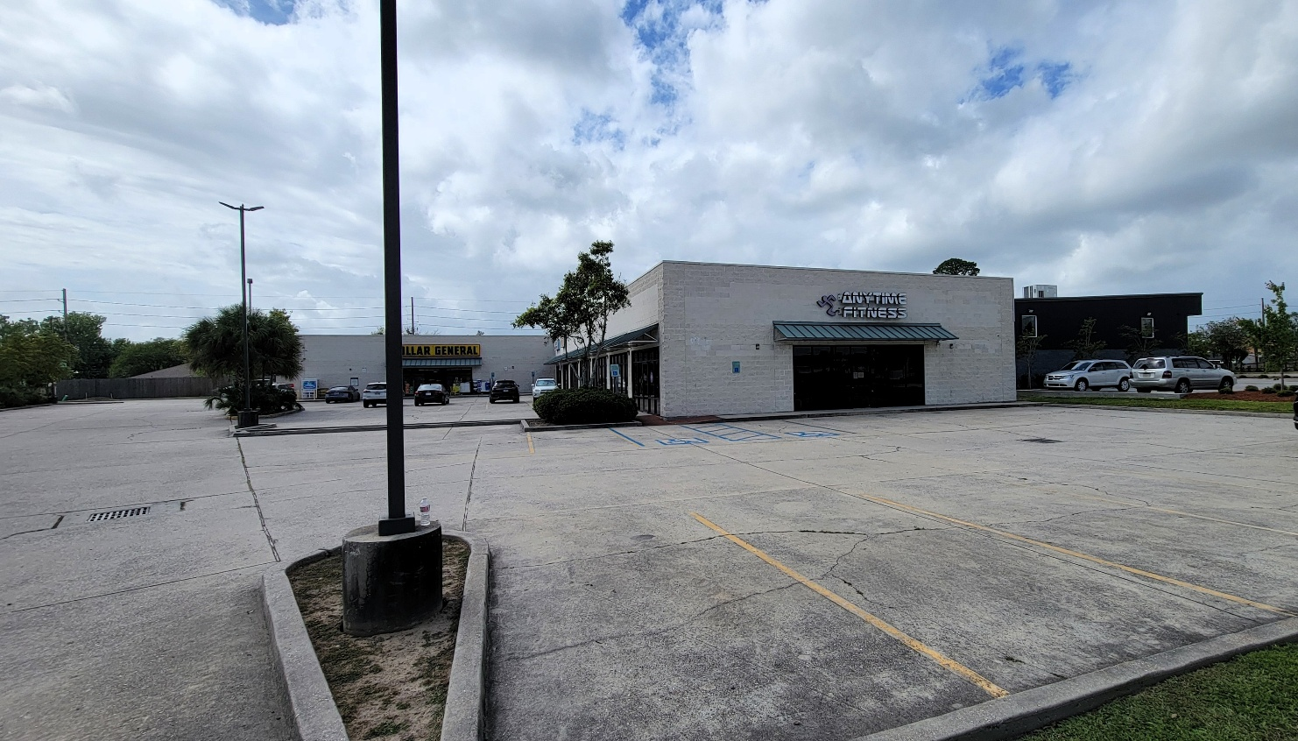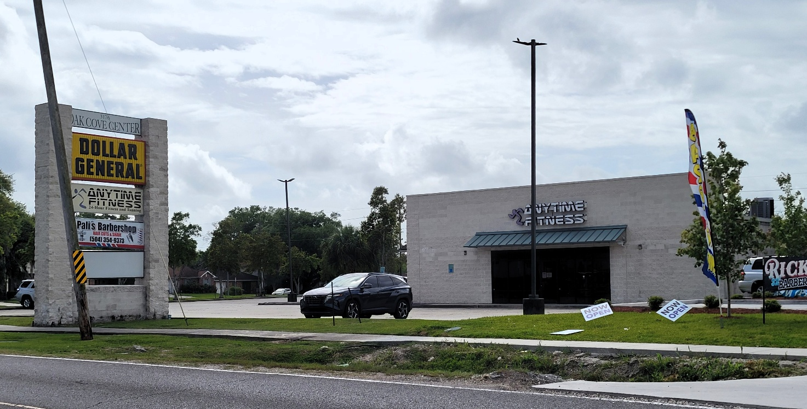

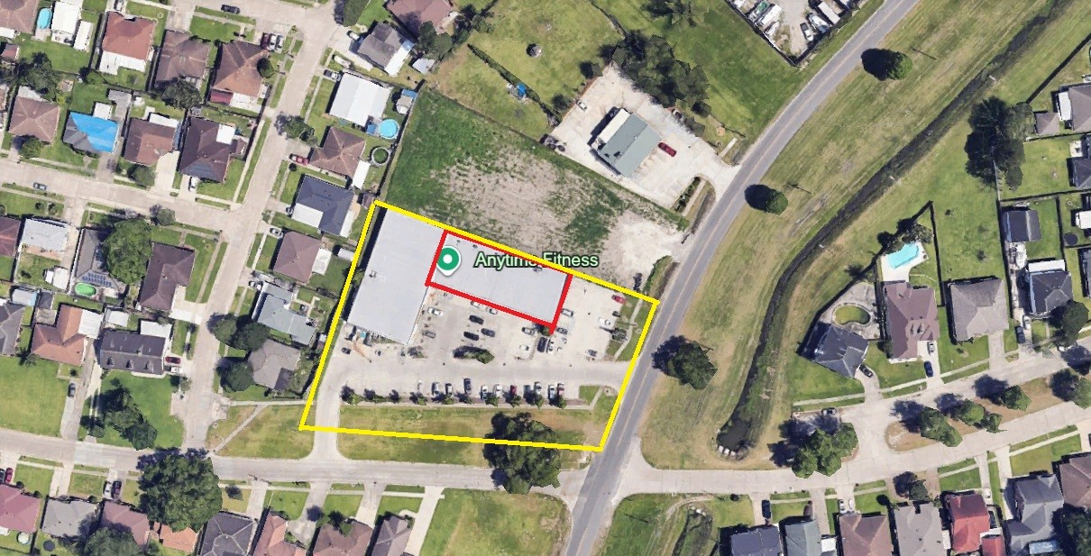

Floor Plan
Space Subdivided

